**Create table commands:**

CREATE TABLE instructors

(instructor_name VARCHAR(50) PRIMARY KEY, -- primary key would ideally be a ID instead, but following specification

office_room VARCHAR(6)) -- allows nulls because budget cuts could mean no office for a new person for a bit

CREATE TABLE students

(student# INT IDENTITY(1,1) PRIMARY KEY,

student_name VARCHAR(50) NOT NULL,

email VARCHAR(50) CONSTRAINT ck_students_email CHECK(email LIKE '_%@_%._%'),

major VARCHAR(50)) -- ideally "majorID INT FOREIGN KEY REFERENCES majors(majorID)" but we don't have that table

CREATE TABLE courses

(course# VARCHAR(8) PRIMARY KEY, -- assuming something like ABCD1234

course_name VARCHAR(50) NOT NULL,

instructor_name VARCHAR(50) FOREIGN KEY REFERENCES instructors(instructor_name))

CREATE TABLE registrations

(student# INTEGER FOREIGN KEY REFERENCES students(student#) ON DELETE CASCADE,

course# VARCHAR(8) FOREIGN KEY REFERENCES courses(course#) ON DELETE CASCADE,

grade CHAR(1),

PRIMARY KEY(student#, course#))

Commands completed successfully.

Completion time: 2020-01-13T08:23:15.3396052-07:00

**Database Diagram:**

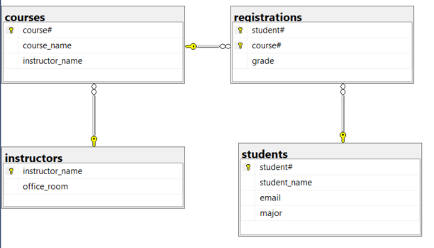

**Insert 2 Records in Each Table:**

INSERT INTO instructors(instructor_name,office_room) VALUES('Tom Hollis','AB245'),('Bob Robertson','CD167')

INSERT INTO students(student_name,email,major) VALUES('Al Albertson','al1234@gmail.com','Accounting'),('Carol Channing','cc123@yahoo.ca','Drama')

INSERT INTO courses(course#,course_name,instructor_name) VALUES('HIKE1234','Hiking Instead of Class','Tom Hollis'),('CLAS4321','Learn a Thing','Bob Robertson')

INSERT INTO registrations(student#,course#,grade) VALUES(1,'HIKE1234','A'),(2,'CLAS4321','A')

(2 rows affected)

(2 rows affected)

(2 rows affected)

(2 rows affected)

Completion time: 2020-01-13T08:36:16.4869791-07:00

**Change all grades for 1 student to a W:**

UPDATE registrations

SET grade='W'

WHERE student#=1

(1 row affected)

Completion time: 2020-01-13T08:38:28.5756959-07:00

**How many students in each course?**

SELECT course_name, COUNT(*) as number_of_students

FROM courses c INNER JOIN registrations r ON c.course#=r.course#

GROUP BY course_name

course_name number_of_students

-------------------------------------------------- ------------------

Hiking Instead of Class 1

Learn a Thing 1

(2 rows affected)

Completion time: 2020-01-13T08:40:35.6749508-07:00

**What instructors haven’t been assigned any courses?**

--need to make an unassigned instructor first to prove it works

INSERT INTO instructors(instructor_name,office_room) VALUES('The New Guy','CLOSET')

SELECT i.instructor_name

FROM instructors i LEFT OUTER JOIN courses c ON i.instructor_name=c.instructor_name

WHERE c.course# IS NULL

(1 row affected)

instructor_name

--------------------------------------------------

The New Guy

(1 row affected)

Completion time: 2020-01-13T08:43:32.1947076-07:00

**Names of Majors that Students are Taking**

SELECT DISTINCT major

FROM students

ORDER by major

major

--------------------------------------------------

Accounting

Drama

(2 rows affected)

Completion time: 2020-01-13T08:45:36.7052265-07:00

**Transcript Summary for All Students**

SELECT student_name,course_name,grade

FROM students s INNER JOIN registrations r ON s.student#=r.student#

INNER JOIN courses c ON r.course#=c.course#

ORDER BY student_name

student_name course_name grade

---------------------------------------- ---------------------------------------- -----

Al Albertson Hiking Instead of Class W

Carol Channing Learn a Thing A

(2 rows affected)

Completion time: 2020-01-13T08:47:21.6269301-07:00

**Delete a Course and its Registrations**

-- before

SELECT * from courses

SELECT * from registrations

SELECT * from instructors

course# course_name instructor_name

-------- ------------------------------------------- -----------------------------------------

CLAS4321 Learn a Thing Bob Robertson

HIKE1234 Hiking Instead of Class Tom Hollis

(2 rows affected)

student# course# grade

----------- -------- -----

1 HIKE1234 W

2 CLAS4321 A

(2 rows affected)

instructor_name office_room

-------------------------------------------------- -----------

Bob Robertson CD167

The New Guy CLOSET

Tom Hollis AB245

(3 rows affected)

-- cascade deleting added to the registration table in anticipation of this question

DELETE FROM courses

WHERE instructor_name='Tom Hollis'

-- after

SELECT * from courses

SELECT * from registrations

SELECT * from instructors

(1 row affected)

course# course_name instructor_name

-------- ------------------------------------------ ------------------------------------------

CLAS4321 Learn a Thing Bob Robertson

(1 row affected)

student# course# grade

----------- -------- -----

2 CLAS4321 A

(1 row affected)

instructor_name office_room

-------------------------------------------------- -----------

Bob Robertson CD167

The New Guy CLOSET

Tom Hollis AB245

(3 rows affected)

Completion time: 2020-01-13T09:11:55.5121339-07:00